**SENTIMENT ANALYSIS:**

The process of computationally identifying and categorizing opinions expressed in a piece of text, especially in order to determine whether the writer's attitude towards a particular topic, product, etc. is positive, negative, or neutral

**WHY DO WE NEED SENTIMENT ANALYSIS?**

Sentiment analysis is extremely useful in social media monitoring as it allows us to gain an overview of the wider public opinion behind certain topics. The applications of sentiment analysis are broad and powerful. The ability to extract insights from social data is a practice that is being widely adopted by organizations across the world. By using sentiment analysis, you gauge how customers feel about different areas of your business without having to read thousands of customer comments at once.

**SENTIMENTS ANALYSIS ON YUTBE COMMENTS:**

Installing libraries:

**Seaborn:**

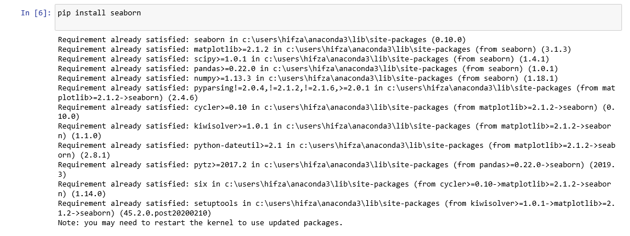

**Textblob:**

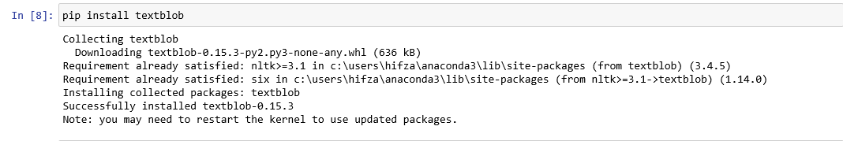

***Importing packages:***

*1. Data Visualization*

*2. Visual Packages*

*3. NLP packages*

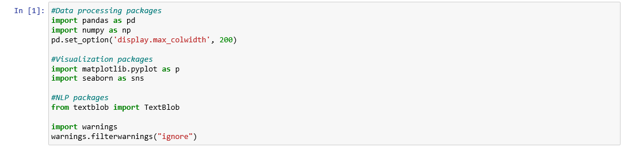

Testing sentiments Analysis sample*;*



Importing Youtube comments Data:

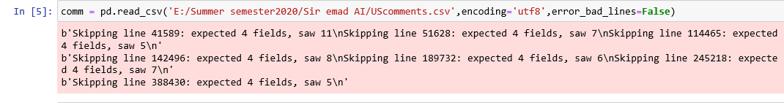

Calculating Sentiment Polarity for Each Comment:

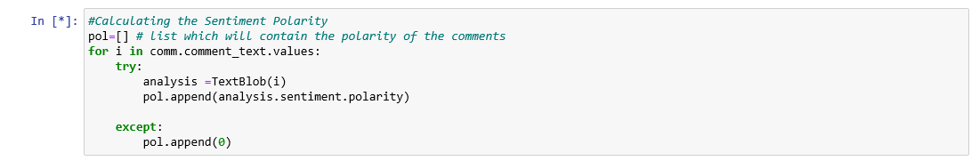

Adding Sentiments Polarity Column to the Data:



Converting the Polarity values To Categorical:



Displaying Positive Comments:



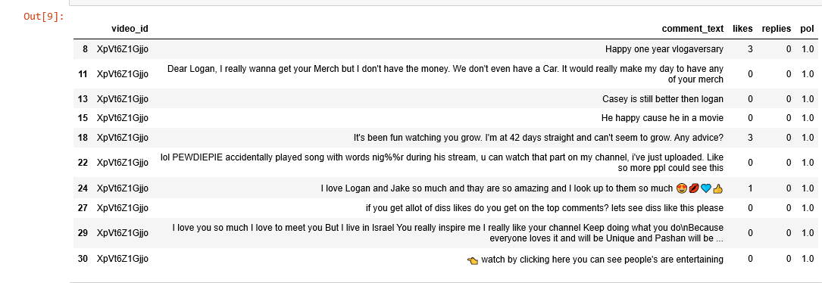

Displaying Negative Comments:



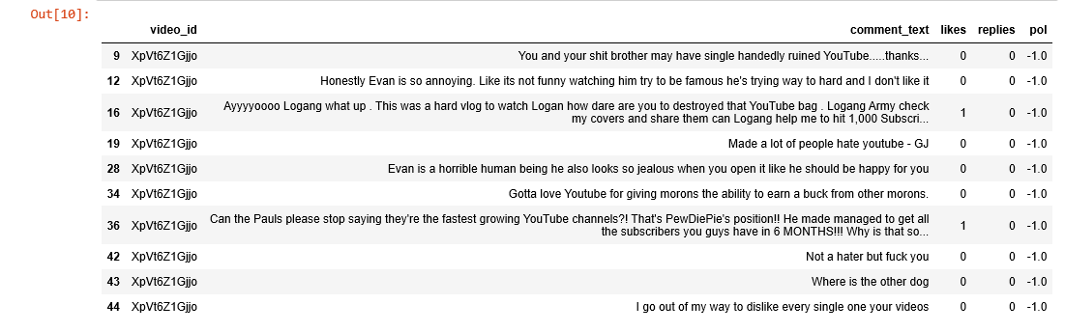

Displaying Neutral Comments:



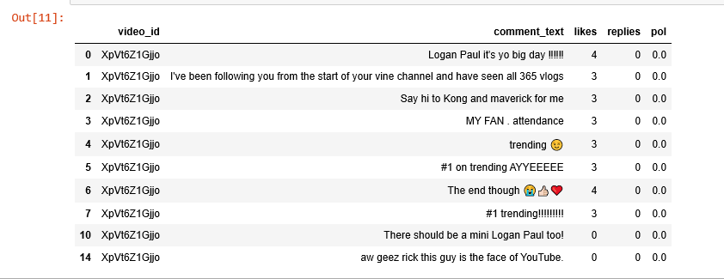

Calculating Count of Positive, Negative and Neutral:



